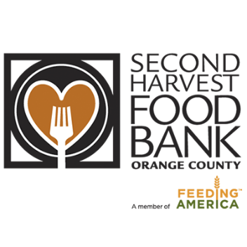

Thank You Email/Letter
Dear [Name, Colleagues, Neighbors],
Congratulations! I am happy to share that the [Organization Name]’s food drive has been successfully completed. With your partnership, we raised [Total Raised $ Amount] in support of Second Harvest Food Bank’s mission to end hunger in Orange County!
More than 301,000 (9.6%) people in OC are at risk of hunger each month and are unsure of where their next meal will come from. With your support, our neighbors will receive high quality, nutritious food when they need it most.
On behalf of all of us here at Second Harvest, we thank you for your donations which will make life a bit brighter and bring hope to those we serve.
To learn more about Second Harvest’s mission and to stay engaged with our work, visit www.FeedOC.org. And to see how your efforts are making a difference in our community, come take a tour or volunteer with us!

With gratitude,
[Your Name]

